36.66: a) 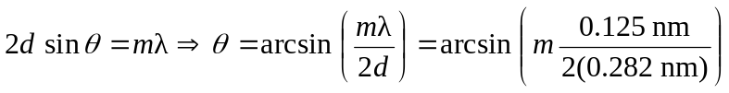
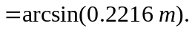
b) If the separation 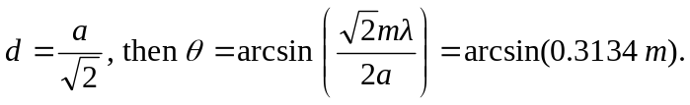
So for No larger values yield answers.

